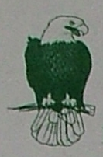
Sterling BillBand
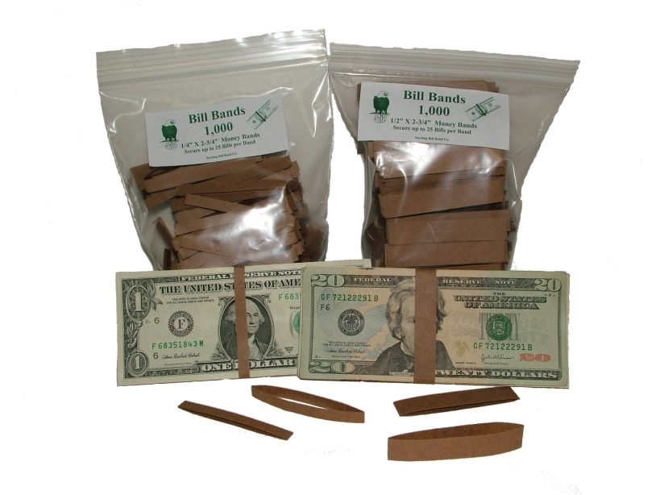
Money Wrap Company
PO Box 395
Sterling, MA 01564

Phone # 978.821.7325
Fax # 978.422.0117
E-mail: sales@sterlingbillband.com
Made in the USA

Quote Request Form
Date __________

Company __________________________________
Address __________________________________
City/Town __________________________________
State _________ Zip Code ______________
Contact Person ___________________________________
Phone # ___________________________________
Fax # ___________________________________
E-mail: ___________________________________

Please estimate your yearly usage of bill bands for best possible price.

Estimated Quantity | Item # | Product Description
units | #501 | ¼” x 2 ¾” Plain Brown Paper Bill Bands
units | #503 | ½” x 2 ¾” Plain Brown Paper Bill Bands

- We will quote price(s) within 24 hours of receipt of request.
- Whether shipping to one location or multiple locations we will work with you for the best delivered price.
- We normally ship FedEx unless otherwise requested.

Additional comments:

“Thank you” for allowing us to quote on your needs.
Warehouse/Shipping Location: 165 Hartwell Street West Boylston, MA 01583

